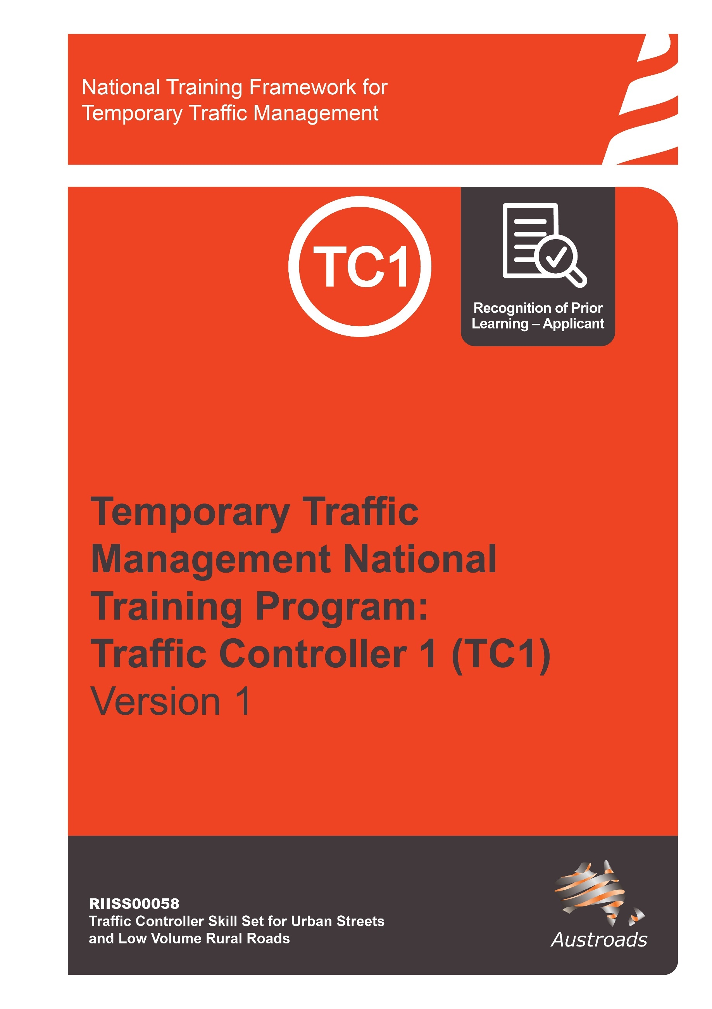

Copyright
© Austroads 2022
This work is copyright. Apart from any use as permitted under the Copyright Act 1968, no part may be reproduced by any process without the prior written permission of Austroads.
This training material has been prepared for Austroads as part of its work to improve transport outcomes in Australian and New Zealand.
The text provided in this document may not be edited.
Only an approved Training Provider is permitted to use this training resource. An Approved Training Provider is a Registered Training Organisation that has been approved by a road agency to deliver this National Temporary Traffic Management Training Program.

Version | Date | Comment
1.0 | October 2022 | Approved – Austroads Temporary Traffic Management Task Force
1.01 | February 2024 | Page 13, Section 12b – Updated. Removed incorrect skills.

Contents

About This Qualification 4
The RPL Application Process 4
Tips and Hints To Help You Prepare For Recognition 5
Preparing your RPL Application 5
RPL Application Form for Traffic Controller TTM Category 1 (RIISS00058) 7

About This Qualification
Traffic Controllers direct the flow and speed of vehicles, and ensure the safety of drivers, pedestrians cyclists and workers. Traffic Controllers are often relied on for manual control of vehicles where automatic lights are unavailable, such as next to road works, construction sites, during public events and as part of a coordinated emergency response.
This Recognition of Prior Learning (RPL) application covers the skills and knowledge required for obtaining the RIISS00058 - Traffic Controller Skill Set for Urban Streets and Low Volume Rural Roads skill set (Traffic Controller 1). This skill set has been created to align to the requirements of individuals responsible for traffic control in temporary traffic management, as described in the Austroads Guide to Temporary Traffic Management on Temporary Traffic Management Category 1 environments. For further information visit Temporary Traffic Management | Austroads
This RPL application covers the content of all units within the RIISS00058 - Traffic Controller Skill Set for Urban Streets and Low Volume Rural Roads skill set which are;

- RIICOM201E Communicate in the workplace
This unit describes the skills and knowledge required to communicate in the workplace in the resources and infrastructure industries and other industries with relevant work practices and procedures. It applies to those working in operational roles where the worker works under supervision to undertake a prescribed range of functions involving known routines and procedures.

- RIIWHS205E Control traffic with stop-slow bat
This unit describes the skills and knowledge required to control vehicle and pedestrian traffic using stop-slow bats, hand signals and approved communication devices in the resources and infrastructure industries. It applies to those working in operational roles. They generally work in teams in live traffic environments under supervision.

- RIIWHS206 Control traffic with portable traffic control devices and temporary traffic signs
This unit describes the skills and knowledge required to monitor and control traffic with portable traffic control devices and temporary traffic signs according to traffic management plans and traffic guidance schemes. It applies to those working in operational roles. They generally work in teams in live traffic environments under supervision.

The RPL Application Process
- Initial discussion with your assessor, this is to answer any questions you may have about the RPL process and for the assessor to determine if you are eligible to apply for RPL.
- Locate evidence of your workplace (practical) experience and formal/informal training.
- Complete and submit the RPL Application form.
- Your assessor will review your application and evidence and, if required, will call you to clarify/discuss further.
- Your assessor will organise for you to meet with them to have a conversation throughout which your assessor will ask questions to gain an understanding of you your workplace experience and knowledge.
- Completion of a written challenge test.

Tips and Hints To Help You Prepare For Recognition
To have your skills and knowledge formally recognised in the national system, assessors must make sure you have the current skills and knowledge to meet the industry standard. This means you must be involved in a careful and comprehensive process that covers the content of all units you can be recognised for.
Your RPL application will be based on providing evidence that you have the skills and knowledge required for units listed on page 4 and that you are (or have in the previous 12 months) worked as a Traffic Controller 1 (on a live category 1 road environment) which includes meeting both the practical and theoretical components of all the units of competency and the skill set.
Here are some tips and hints for you:
- Be prepared to talk about your job roles and work history. Have an up-to-date resume or, at the least, jot down a few points about where you have worked, either paid or unpaid, and what you did there that relate to your application.
- Locate your current position description and any performance appraisals (if available).
- Contact a third party referee – that is someone in your current and/or previous workplace that would be happy to verify your skills and you're comfortable with them discussing this with an assessor. Remember referees need to be a current or recent (from the past 12 months) supervisor/ team leader.
You may also have community contacts from volunteer work that can confirm your skills.
- Collect any certificates from in-house or formal training you have successfully completed.
- Other forms of evidence could include letters from employers, records of your professional development sessions, employers or clients in related industries or government agencies, acknowledgements, workplace forms or other relevant documents.
- Have an understanding of the Austroads Guide to Temporary Traffic Management – Parts 1 to 10 – this will be particularly important when you sit your theory assessment. In particular Part 7 which relates to Traffic Controllers.

Preparing your RPL Application
Complete the RPL Application form noting any evidence you will require.
Step 1 Collect Evidence
Documents you may provide to support your application include:
Workplace documents
- Any licences/tickets/authorisations
- Resume or details of work history
- certificates from in-house or formal training courses completed.
- Diaries/task sheets/job sheets/log books
- Site training records
- Site competencies held record
- references/letters from current and/or previous employers/supervisors
Remember you will need to supply contact details of one or two work referees (third parties) who can confirm your skills.
Step 2 Submit the evidence and application
- Collect the evidence you need to support your application
- Remember, you are signing a declaration stating that the information you provide, including any copies of documents or licenses you are supplying as evidence, is authentic.

Step 3 Assessor to check
The assessor will check the evidence you have provided and if required contact you by phone or email to clarify anything unclear or missing.
Step 4 Conversation with Assessor
The conversation provides an opportunity for you to confirm your skills and experience identified in your RPL application. This will also confirm your industry currency and understanding of the Austroads Guide to Temporary Traffic Management, Australian Standards and jurisdictional specific standards.
Step 5 Completion of Challenge Test
You will be given a date/time by your Approved Training Provider (ATP) to complete a challenge test.
Step 5 Notification
The ATP assessor will contact you to discuss the outcome of your RPL application.

RPL Application Form for Traffic Controller TTM Category 1 (RIISS00058)

1 Personal Details
Surname: | Title: Mr/Mrs/Ms/Miss/Dr/other
First Name: | Middle Name(s):
Date of Birth:
Home Address:
Suburb: | Postcode
Postal Address (if different from above)
Suburb: | Postcode
Phone Number: | Work Phone:
Email:
2. Current Employment
Are you currently employed? ☐ Yes ☐ No
If yes, is your occupation related to the skill set you are seeking RPL for? ☐ Yes ☐ No
What is the name of your employer?
Please provide details of the workplace:
Name:
Address:
Type of workplace (profession):

3. Formal Training / Qualifications
Have you completed any nationally recognised training related to industry? ☐ Yes ☐ No
Name of course or qualification | Completion date (month, year) | Country | Name of Training Organisation

4. Other Training/Certificates Completed (non-accredited)
Name of course or qualification | Completion date (month, year) | Country | Name of Training Organisation

5. Workplace Validation  Complete the column marked A (applicant) by placing a tick or a cross to show if you can address the requirement (tick = yes, cross = no). |  | A | V
1 | Controlled traffic using a stop/slow bat on at least 2 occasions.
2 | Must have directed pedestrian traffic on at least one occasion. Pedestrian traffic must include:  - those with mobility issues OR  - pedestrians with prams OR  - cyclists  (applicant to identify which of the above categories is relevant)
3 | Coordinated operations with a pilot vehicle in a shuttle flow arrangement
4 | Completed at least one incident report  (attach a copy of an incident report generated by the applicant)
5 | Controlled traffic using a PTCD (either a PTSS or boom barrier) on at least two occasions.
6 | Evidence of a minimum of 20 hours undertaking the above (no clarity required around percentage of PTCD / Stop-Slow bat)
7 | Operate communication devices correctly including ensuring devices are fit for purpose, communication is delivered in a clear and concise manner; take, confirm and pass on messages promptly to others and use correct terminology.

6. Evidence Table
When you collect your evidence, write what the evidence is in the ‘attached evidence table’ and align the line number on the first table with the letter which corresponds to the evidence you are providing. Remember, you are signing a declaration stating that the information you provide, including any copies of documents or licenses etc. you are supplying as evidence, is authentic.  Attached evidence table (add lines as required) |  | What numbered row/s does this align to in the table above?
A
B
C
D
E
F
G
H

Third Party Declaration
Who should complete this tool?
This tool is to be completed by someone who is currently working or has previously worked (within the last 12 months), in a supervisory capacity to the applicant and can confirm their skills and knowledge as relevant to workplace performance.

What do I have to do?
Complete the Referee Testimonial on the next page.

How are my comments used in the assessment decision?
There are no right or wrong answers. It is your perception or opinion that is important. You are not providing the assessment decision; however, your comments will assist the assessor in forming their final opinion of the applicant’s competence. The applicant will provide a range of evidence to help the assessor make the final decision.

Third Party Declaration - Personal Details
Name:
Position Title:
Organisation:
Suburb: | Postcode:
Phone Number: | Work Phone:
Email:
Length of time you have worked with the applicant
☐ Less than 1 year ☐ 1–2 years ☐ 2–5 years ☐ More than 5 years

Tick the skills the applicant has successfully completed in the workplace
Plan and Prepare for Work
- Arrive for work fit for duty (not fatigued, dressed, and presented suitably, correct PPE) | ☐
- Access, interpret and apply relevant documentation, policies and procedures, including (please tick those that are applicable):  ☐ TGS ☐ TMP  ☐ Work instructions ☐ SWMS/JSEA  ☐ Correct radio channel identified ☐ Emergency procedure  ☐ Supervisor name and contact details captured ☐ Site specific safety documents  ☐ Austroads Guide to Temporary Traffic Management Parts 7 & 8 (if applicable) ☐ Escape path identified and confirmed  ☐ Discussed with Supervisor the specific risk presenting on the site. | ☐
- Participated in Pre-start briefing and asked questions where appropriate to ensure understanding of work and site requirements | ☐
- Confirmed and ask questions to gain clarity on work instructions and site requirements and identify site specific risks with appropriate site personnel | ☐
- Confirmed and clarified environmental protection requirements with appropriate site personnel and information in TMP, SWMS and/or JSEA | ☐
- Appropriately select and check the serviceability of the following:  ☐ PPE ☐ UHF radio  ☐ High visibility clothing ☐ Sign covers  ☐ Wand or torch (night work only) ☐ Industry authority (if applicable)  ☐ Radio battery plus spare charged ☐ STOP/SLOW bat Correct size and height – no damage  ☐ Traffic Controller Ahead/PREPARE TO STOP sign/TC Symbolic  ☐ Notebook and pen  ☐ Other (list): | ☐
- Identify faulty or non-compliant tools and equipment:  Rectify and/or isolate and report faults according to Standard Operating Procedures (SOP). | ☐
- Follow and meet Austroads Guide to Temporary Traffic Management Parts 7 and 8 requirements including:  ☐ Confirm speed limit < 60 km/h ☐ Escape path is clear  ☐ Confirm Prepare to Stop sign in correct location ☐ Traffic cones (in advance of traffic control position) are spaced and placed correctly  ☐ Confirm their position ensures the appropriate sight distance for approaching vehicles ☐ Confirm Stop/Giveway signs are covered (if applicable and approved) | ☐
- Apply safe manual handling procedures when lifting, pushing, pulling, holding, and/or carrying equipment | ☐
- Confirm that any pre-positioned temporary traffic signs and barriers meet the requirements of the site traffic management plan:  ☐ Confirms adjustments are correct and meet site traffic management plan ☐ Report non compliances or concerns to supervisor/TMI | ☐
- Stand in the correct position ad location to provide clear direction to traffic, including:  ☐ TC in advance of TC taper or past merge taper ☐ TC is not obstructing any signs or devices  ☐ Facing oncoming traffic ☐ Correct sighting distance as per TMP | ☐
- Direct traffic correctly using a STOP/SLOW bat, including:  ☐ Bat at correct height (1.8 metres) ☐ Communicate with other TC/TCs regarding traffic ‘on hold’ and volume  ☐ Display STOP/SLOW bat in a clear manner to road users – no jittery or shaky movements ☐ Identify the last vehicle received if traffic released by other TC  ☐ Stop initial traffic from shoulder of road (outside of travel path) ☐ Check work area activity prior to sending vehicles  ☐ Use correct and clear hand signals to stop vehicles ☐ Confirm it is safe to release traffic with second TC prior to sending vehicles  ☐ Adjust position (move to in line with driver’s side headlight) to ensure they remain clearly visible to approaching traffic after 2-3 vehicles have stopped ☐ Step back out of the travel path, made eye contact with driver, turn STOP/SLOW bat to SLOW and use correct and clear hand signals to send traffic  ☐ Stop initial traffic approximately 6 metres in front of TC position ☐ Communicate last vehicle details after sending and returned to stop.  ☐ Other (list): | ☐
12b. Direct traffic correctly, operating a PTCD including:  ☐ Ensuring PTCD in correct position ☐ Operate the PTCD  ☐ Stop initial traffic from shoulder of road (outside of travel path) ☐ Communicate with second TC regarding traffic ‘on hold’ and volume  ☐ Identify the last vehicle received if traffic released by other TC ☐ Confirm it is safe to release traffic with second TC prior to sending vehicles  ☐ Stop initial traffic approximately 6 metres in front of TC position  If a programmed PTCD is being used:  ☐ Ensure the PTCD is positioned correctly ☐ Constantly check queue lengths  ☐ Monitor the PTCDs operation ☐ Report any issue to Supervisor | ☐
- Monitor traffic conditions and adjust as necessary, on more than one occasion including:  ☐ Inappropriate behavior from drivers ☐ Duration of queue  ☐ For changes to environmental conditions ☐ Length of queue  ☐ Adjust position to ensure they are clearly visible by approaching traffic, after 2-3 vehicles have stopped ☐ Sighting distance and adjust position to ensure clarity | ☐
- Able to explain how to manage queue length:  ☐ Report to appropriate person ☐ Follow instructions provided | ☐
- Able to explain why traffic controllers should avoid stopping large vehicles at the front of the queue and ensure vehicles have a safe braking distance.  ☐ Ensure other drivers behind first vehicle can see hand/bat signals ☐ Safety  ☐ Provide greater visibility for TC and public | ☐
- Direct pedestrians correctly including:  ☐ Stand in appropriate position ☐ Made eye contact  ☐ Give appropriate directions – polite manner ☐ Use appropriate hand signals | ☐
- Operate communication devices correctly including:  ☐ Adjust controls to achieve optimum reception results ☐ Communicated in a clear and concise manner  ☐ Monitor the power levels of communication devices ☐ Take, confirm and pass on messages promptly to others  ☐ Conduct a communications check following a period of non-contact with site personnel ☐ Replaced batteries  ☐ Ask questions to clarify information received as required ☐ Use correct terminology | ☐
- Capture details and report traffic offenders correctly including:  ☐ Note driver(s) description or name, contact details and D/L number ☐ Forward report to supervisor in a timely manner  ☐ Complete incident report accurately with all relevant information ☐ Report to other Traffic Controllers  ☐ Note time, date, location, description of event ☐ Report to supervisor as soon as it is safe to do so  ☐ Note vehicle(s) rego, make, model, colour | ☐
- Clean up traffic control station according to requirements including:  ☐ In conjunction with TMI person/supervisor, pack up PTCD (when used) ☐ Pack up cones installed at the traffic control station  ☐ Remove and clean traffic control station signs if site is not required ☐ Cover sign if site continues | ☐
- Clean, check, maintain and store tools and equipment at the completion of the task including:  ☐ UHF radio, checked and charged ☐ Remove personal rubbish  ☐ Wand/torch checked and charged (if applicable) ☐ Remove and clean sign/s if site is finished | ☐

I certify that (add name of applicant) has undertaken the activities as ticked above.
If you would like any further information please feel free to contact me.
Signature
Print Name and Position
Company

APPLICANT DECLARATION
The information I have provided is true and correct. The evidence to support my claims is authentic.

Applicant name (print) _______________________________________
Applicant signature _________________________________________
Applicant contact phone _____________________________________

Please return this application form with relevant evidence to:

traffic@startraining.com.au

Your ATP will review your application and contact you:
- Date/times for competency conversation and completion of challenge test

