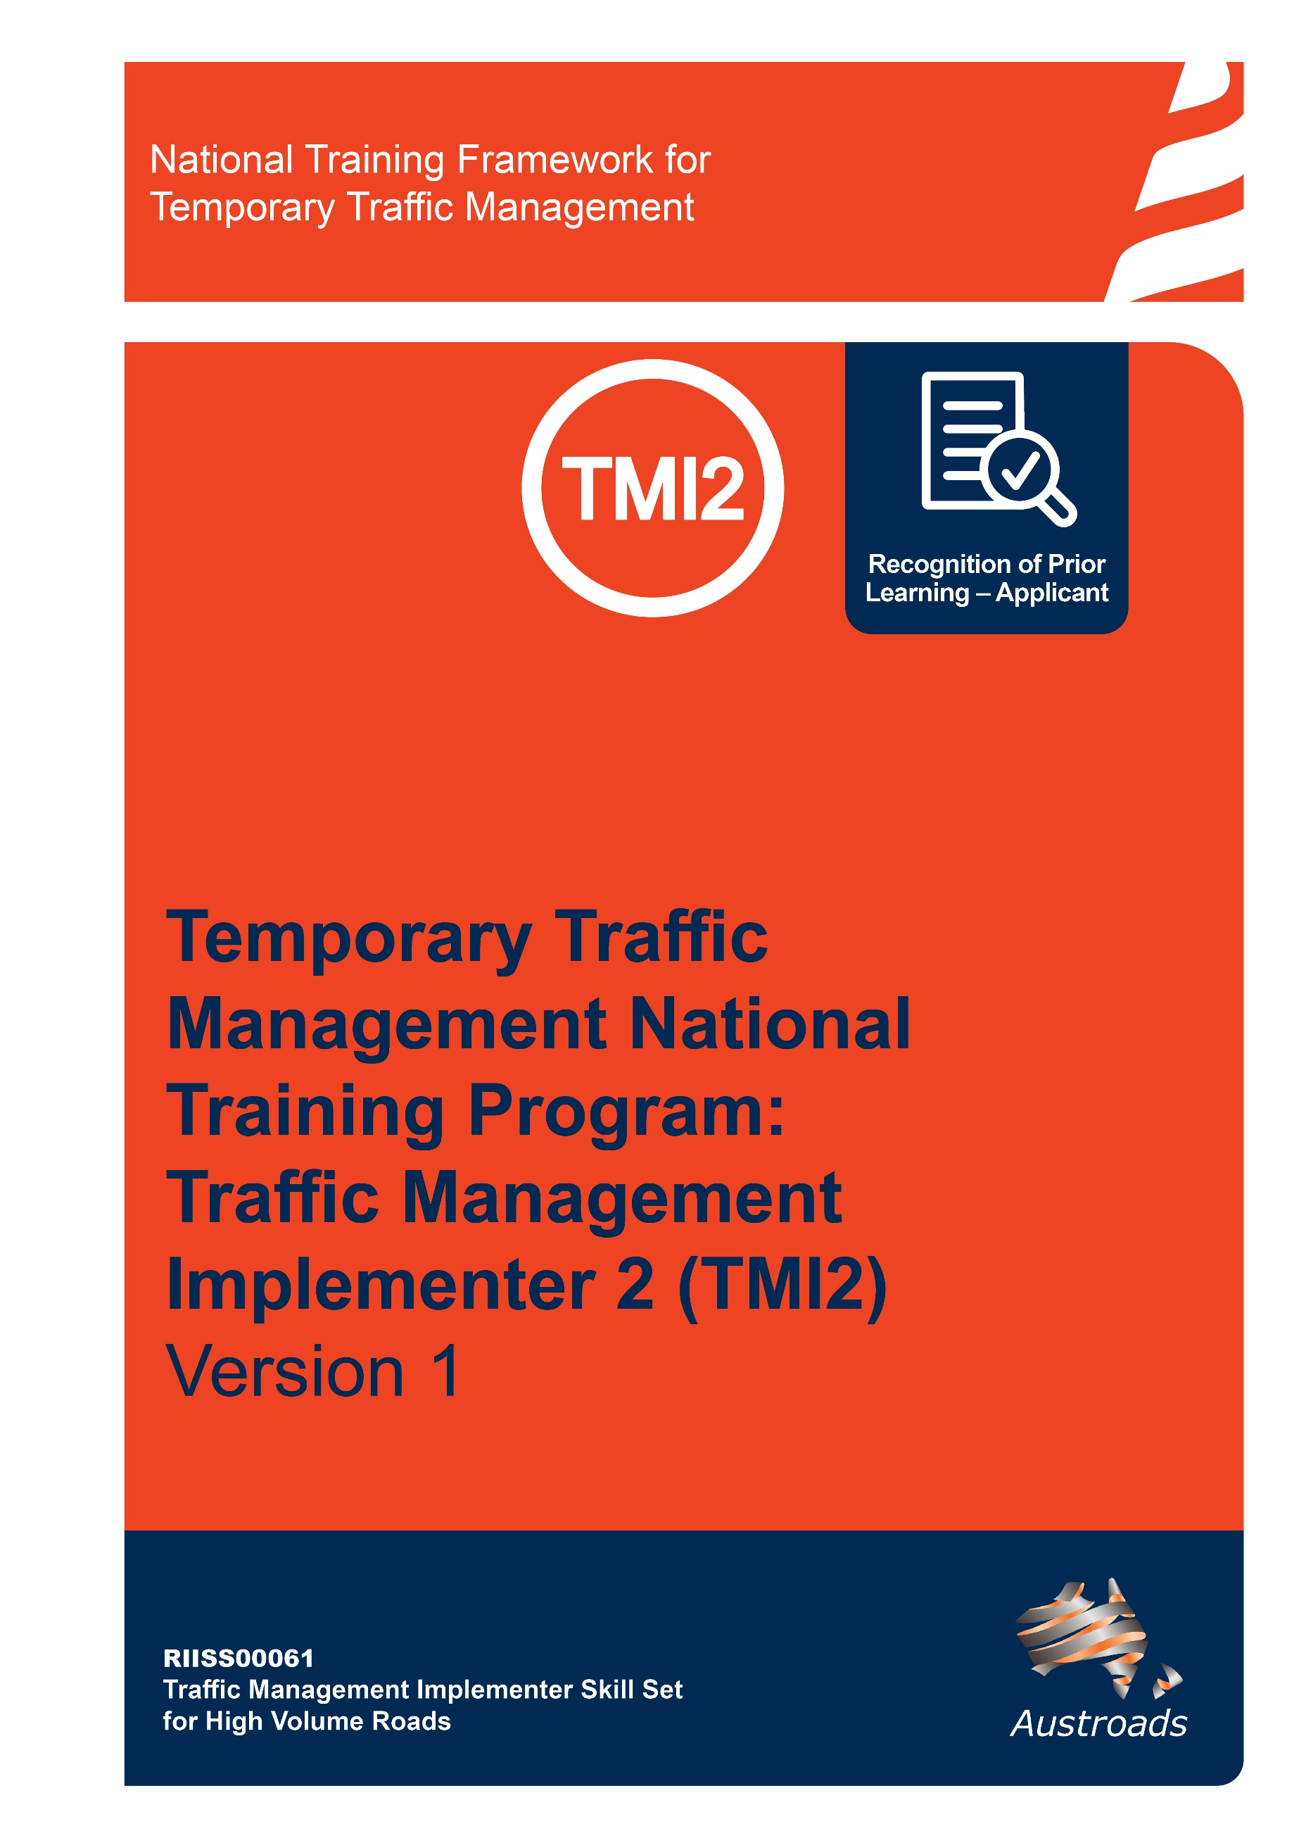

**Copyright**

© Austroads 2022

This work is copyright. Apart from any use as permitted under the *Copyright Act 1968,* no part may be reproduced by any process without the prior written permission of Austroads.

This training material has been prepared for Austroads as part of its work to improve transport outcomes in Australian and New Zealand.

The text provided in this document may not be edited.

Only an approved Training Provider is permitted to use this training resource. An Approved Training Provider is a Registered Training Organisation that has been approved by a road agency to deliver this National Temporary Traffic Management Training Program.

|  |  |  |
| --- | --- | --- |
| Version | Date | Comment |
| 1.0 | October 2022 | Approved – Austroads Temporary Traffic Management Task Force |

**Contents**

**Copyright** 2

**About This Qualification** 4

**The RPL Application Process** 5

**Tips and Hints To Help You Prepare For Recognition** 6

Preparing your RPL Application 6

**RPL Application Form for Traffic Management Implementer TTM Category 2 (RIISS00061)** 8

# **About This Qualification**

A Traffic Management Implementer is the person in charge of implementing the TTM at each worksite and is responsible for recording and summarising all adjustments or approved modifications made to the TTM on the TMP and TGS. Additionally, they are responsible for monitoring the performance and effectiveness of the implemented TGS.

This Recognition of Prior Learning (RPL) application covers the skills and knowledge required for obtaining the RIISS00061 – Traffic Management Implementer – High Volume Roads skill set (Traffic Management Implementer 2). This skill set has been created to align to the requirements of individuals responsible for traffic management implementation on a site and road workers under their direction, as described in the Austroads Guide to Temporary Traffic Management on Temporary Traffic Management Category 2 environments. For further information visit [Temporary Traffic Management | Austroads](https://austroads.com.au/network-operations/temporary-traffic-management/training/riiss0061)

This RPL application covers the content of all units within the RIISS00061 – Traffic Management Implementer – High Volume Roads skill set which are;

* RIIBEF301D Run on-site operations

This unit describes a participant’s skills and knowledge required to run on-site operations in the Resources and Infrastructure Industries. This unit is appropriate for those working in operational or supervisory roles.

* RIIWHS304 Implement traffic management plans on high volume roads

This unit describes the skills and knowledge required to set out, monitor and close down traffic management plans and traffic guidance schemes on high volume roads and signalised intersections requiring temporary traffic management. It applies to those working in supervisory roles. They generally work in teams in live traffic environments and hold some responsibility for the outcomes of others. This unit applies to temporary traffic management on roads that include the following characteristics, excluding motorways and freeways:

* + speeds limits greater than or equal to 60km/h and traffic volumes greater than or equal to 3,000 vehicles per day (Average Annual Daily Traffic (AADT)); or
  + any speed limit and greater than 10,000 vehicles per day (AADT); or
  + any signalised intersection.

This unit is appropriate for individuals who have completed at least 12 temporary traffic management set ups within the last 12 months, including at least one higher speed or higher volume road set up.

# **The RPL Application Process**

1. Initial discussion with your assessor, this is to answer any questions you may have about the RPL process and for the assessor to determine if you are eligible to apply for RPL.
2. Locate evidence of your workplace (practical) experience and formal/informal training.
3. Complete and submit the RPL Application form.
4. Your assessor will review your application and evidence and, if required, will call you to clarify/discuss further.
5. Your assessor will organise for you to meet with them to have a conversation throughout which your assessor will ask questions to gain an understanding of you your workplace experience and knowledge.
6. Completion of a written challenge test.

# **Tips and Hints To Help You Prepare For Recognition**

To have your skills and knowledge formally recognised in the national system, assessors must make sure you have the current skills and knowledge to meet the industry standard. This means you must be involved in a careful and comprehensive process that covers the content of all units you can be recognised for.

Your RPL application will be based on providing evidence that you have the skills and knowledge required for units listed on page 4 and that you are (or have in the previous 12 months) worked as a Traffic Management Implementer 1 (on a live category 1 road environment) which includes meeting both the practical and theoretical components of all the units and skill set.

Here are some tips and hints for you:

1. Be prepared to talk about your job roles and work history. Have an up-to-date resume or, at the least, jot down a few points about where you have worked, either paid or unpaid, and what you did there.
2. Locate your current position description and any performance appraisals (if available).
3. Consider a third party referee – that is someone in your current and/or previous workplace that would be happy to verify your skills and you are comfortable with them discussing this with an assessor. Remember referees need to be a current or recent (from the past 12 months) supervisor/ team leader.

You may also have community contacts from volunteer work that can vouch for your skills.

1. Collect any certificates from in-house or formal training you have successfully completed.
2. Other forms of evidence could include letters from employers, records of your professional development sessions, employers or clients in related industries or government agencies, acknowledgements, workplace forms or other relevant documents.

## Preparing your RPL Application

Complete the RPL Application form noting any evidence you will require.

**Step 1 Collect Evidence**

Documents you may provide to support your application include:

Workplace documents

* Any licences/tickets/authorisations
* Resume or details of work history
* certificates from in-house or formal training courses completed.
* Diaries/task sheets/job sheets/log books
* Site training records
* Site competencies held record
* references/letters from current and/or previous employers/supervisors

Remember you will need to supply contact details of one or two work referees (third party) who can confirm your skills.

**Step 2 Submit the evidence and application**

1. Collect the evidence you need to support your application
2. Remember, you are signing a declaration stating that the information you provide, including any copies of documents or licenses you are supplying as evidence, is authentic.

**Step 3 Assessor to check**

The assessor will check the evidence you have provided and if required contact you by phone or email to clarify anything unclear or missing.

**Step 4 Conversation with Assessor**

The conversation provides an opportunity for you to confirm your skills and experience identified in your RPL application. This will also confirm your industry currency and understanding of the Austroads Guide to Temporary Traffic Management, Australian Standards and jurisdictional specific standards.

**Step 5 Completion of Challenge Test**

You will be given a date/time by your Approved Training Provider to complete a challenge test.

**Step 5 Notification**

The ATP will contact you to discuss the outcome of your RPL application.

# **RPL Application Form for Traffic Management Implementer TTM Category 2 (RIISS00061)**

|  |  |
| --- | --- |
| **1 Personal Details** | |
| **Surname:** | **Title:** Mr/Mrs/Ms/Miss/Dr/n/a |
| **First Name:** | **Middle Name(s):** |
| **Date of Birth:** | |
| **Home Address:** | |
| **Suburb:** | **Postcode** |
| **Postal Address** (if different from above) |  |
| **Suburb:** | **Postcode** |
| **Phone Number:** | **Work Phone:** |
| **Email:** | |

|  |
| --- |
| **2. Current Employment** |
| **Are you currently employed?**   Yes  No |
| **If yes, is your occupation related to the qualification you are seeking RPL for?**  Yes  No |
| **What is the name of your employer?** |
| **Please provide details of the workplace:** Name:  Address:  Type of workplace (profession): |

|  |  |  |  |
| --- | --- | --- | --- |
| **3. Formal Training / Qualifications** | | | |
| **Have you completed any nationally recognised training related to industry?**  Yes  No | | | |
| **Name of course or qualification** | **Completion date (month, year)** | **Country** | **Name of Training Organisation** |
|  |  |  |  |
|  |  |  |  |
|  |  |  |  |
|  |  |  |  |
|  |  |  |  |
|  |  |  |  |

|  |  |  |  |
| --- | --- | --- | --- |
| **4. Other Training/Certificates Completed (non-accredited)** | | | |
| **Name of course or qualification** | **Completion date (month, year)** | **Country** | **Name of Training Organisation** |
|  |  |  |  |
|  |  |  |  |
|  |  |  |  |
|  |  |  |  |
|  |  |  |  |
|  |  |  |  |

|  |  |  |  |
| --- | --- | --- | --- |
| **5. Workplace Validation**  Complete the **column marked A** (applicant) by placing a tick or a cross to show if you can address the requirement (tick = yes, cross = no). | | **A** | **V** |
| Your evidence must demonstrate implementing traffic management plans on high volume and signalised intersections on at **least three separate live traffic projects**, including: | | | |
| 1 | Evidence of completing at **least two** of the following: |  |  |
| * lane closure on a high-volume road using an electronic signalling device |  |  |
| * static works involving a signalised intersection |  |  |
| * night works |  |  |
| * pedestrian controls at signalised intersections |  |  |
| * contra-flow |  |  |
| * shuttle flow |  |  |
| 2 | Evidence of setting out traffic guidance schemes for **at least two** of the following: |  |  |
| * truck mounted attenuators |  |  |
| * variable message signs |  |  |
| * variable speed limit signs |  |  |
| * safety barriers |  |  |
| * changing work site requirements |  |  |
| * over dimension vehicles |  |  |
| * portable traffic control devices |  |  |

|  |  |  |
| --- | --- | --- |
| **6. Evidence Table** | | |
| When you collect your evidence, write what the evidence is in the ‘attached evidence table’ and align the line number on the first table with the letter which corresponds to the evidence you are providing. Remember, you are signing a declaration stating that the information you provide, including any copies of documents or licenses etc. you are supplying as evidence, is authentic.  Attached evidence table (add lines as required) | | What numbered row/s does this align to in the table above? |
| A |  |  |
| B |  |  |
| C |  |  |
| D |  |  |
| E |  |  |
| F |  |  |
| G |  |  |
| H |  |  |

**Third Party Declaration**

**Who should complete this tool?**

This tool is to be completed by someone who is currently working or has previously worked (within the last 12 months), in a supervisory capacity to the applicant and can confirm their skills and knowledge as relevant to workplace performance.

**What do I have to do?**

Complete the Referee Testimonial on the next page.

##### **How are my comments used in the assessment decision?**

There are no right or wrong answers. It is your perception or opinion that is important. You are not providing the assessment decision; however, your comments will assist the assessor in forming their final opinion of the applicant’s competence. The applicant will provide a range of evidence to help the assessor make the final decision.

|  |  |
| --- | --- |
| **1 Third Party Declaration - Personal Details** | |
| **Name:** | |
| **Position Title:** | |
| **Organisation:** | |
| **Suburb:** | **Postcode:** |
| **Phone Number:** | **Work Phone:** |
| **Email:** | |
| Length of time you have worked with the applicant  Less than 1 year  1–2 years  2–5 years  More than 5 years | |

|  |  |  |
| --- | --- | --- |
| **TICK THE SKILLS THE APPLICANT HAS SUCCESSFULLY COMPLETED IN THE WORKPLACE** | | |
| 1 | Arrived for work fit for duty (has own PPE, not tired, not impaired by alcohol or drugs).  Attended pre-start or handover meetings |  |
| 2 | Accessed and reviewed the content of the job pack, including Traffic Management Plan (TMP), Traffic Guidance Scheme (TGS) and identified work site requirements, including: |  |
| * type of work |  |
| * start/finish time |  |
| * emergency procedures |  |
| * safe working and environmental – SWMS/JSEA |  |
| * permit requirements |  |
| * communication systems |  |
| * qualified personnel and resources – type and number |  |
| * site specific safety documents, including risk assessment and residual risk register |  |
| * signage sequence |  |
| * equipment requirements |  |
| 3 | Confirmed the TMP and TGS was suitable for the site conditions, work activities, and conditions, including: | |
|  | * signage sequence |  |
|  | * traffic volume as per TGS, is accurate |  |
|  | * vulnerable road user movement projection is accurate |  |
|  | * confirm intersection and control signal changes are approved by traffic control centres |  |
|  | * weather conditions |  |
|  | * align with project scope and project requirements |  |
|  | * contact the Traffic Management Designer / Supervisor if they needed clarification on TMP / TGS implementation. |  |

|  |  |  |
| --- | --- | --- |
| **TICK THE SKILLS THE APPLICANT HAS SUCCESSFULLY COMPLETED IN THE WORKPLACE** | | |
| 4 | Reviewed the residual risk from TMP and identified, addressed and reported potential risks, hazards and environmental issues and determined control measures including | |
| * using risk assessment processes |  |
| * confirming unacceptable risk criteria and levels |  |
| * involving others in risk management process |  |
| * uses industry terminology |  |
| * documenting correctly |  |
| * traffic volume and composition |  |
| * feasibility of controls |  |
| * incident and emergency response |  |
| * gaining approval where necessary to implement |  |
| 5 | Identifies/participates in the identification of adjustments required to SWMS/JSA and risk documentation based on site conditions, likelihood and risk of an incident occurring where applicable. |  |
| * consult using terminology and confirming understanding |  |
| * identify feasible control options and selects viable resourced controls |  |
| * pass on changed information |  |
| 6 | Calculate, identify, confirm authorisation, and suitably document all necessary resources where available including: |  |
| * request personnel if required |  |
| * manage within budgets provided |  |
| * ensure consumables are supplied and sufficient throughout |  |
| * vehicles |  |
| * operational safety equipment and PPE |  |
| 7 | Confirm required effective liaison and communication activities were functional and carried out by all according to instructions and procedures |  |
| 8 | Provide suitable, clear instructions daily to Traffic Control (TC) personnel, and initially to new site personnel and site visitors |  |
| 9 | Implements TGS and risk management strategies in conjunction with others dealing appropriately with risks, hazards and deviations not yet addressed |  |
| 10 | Position and re-check TGS signs and devices are accurately positioned, installed correctly and compliantly |  |

|  |  |  |
| --- | --- | --- |
| **TICK THE SKILLS THE APPLICANT HAS SUCCESSFULLY COMPLETED IN THE WORKPLACE** | | |
| 11 | Check and confirm pedestrian pathways, cycle lanes, public transport stops, and signs and devices are accurately positioned and installed correctly and are safe for use |  |
| 12 | Coordinate/carry out any adjustments of signage or devices within tolerances and their role, keeping accurate records and applying for new resources as required. |  |
| 13 | Contact the TMD if modifications were required to the TGS |  |
| 14 | Confirm traffic management plan is implemented correctly and report to supervisor in charge of site so roadwork crew can begin activities |  |
| 15 | Confirm self and roadwork crew were using correct PPE, protected from work site hazards and the work site is emergency management accessible |  |
| 16 | Monitor work activities and apply required measures to mitigate and address emergencies and non-conformance |  |
| 17 | Respond to incidents of offending road users, observing privacy requirements, appropriately |  |
| 18 | Confirm and ensure separation between workers and live traffic, ensuring monitoring of site traffic flow to confirm TGS is effective |  |
| 19 | Ensure traffic is controlled to protect work crew removing traffic control devices providing project updates regularly |  |
| 20 | Close of site: Direct and provide clear and concise instructions to personnel removing signs and devices as per the TGS and manufacturers specifications to ensure: |  |
| 21 | Ensure the work area is appropriately cleared of signage, devices and contamination, leaving minimal environmental impact. |  |
| 22 | Ensure tools and equipment are safely cleaned, checked, maintained and stored to housekeeping procedure requirements and manufacturers specifications, including accurate recording of activities. |  |

I certify that (**add name of applicant)** has undertaken the activities as ticked above.

If you would like any further information please feel free to contact me.

|  |  |
| --- | --- |
| **Signature** |  |
| **Print Name and Position** |  |
| **Company** |  |

**Applicant Declaration**

The information I have provided is true and correct. The evidence to support my claims is authentic.

Applicant name (print) _______________________________________

Applicant signature _________________________________________

Applicant contact phone _____________________________________

Please return this application form with relevant evidence to:

[traffic@startraining.com.au](mailto:traffic@startraining.com.au)

Your ATP will review your application and contact you:

* Date/times for competency conversation and completion of challenge test

