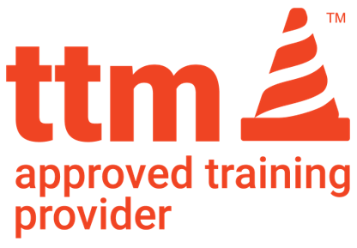

AUSTROADS UTILITY WORKER TRAINING DECLARATION

**ATP NAME: Star Training and Assessing**

**To Star Training and Assessing –** We wish to confirm that the employee(s) listed below are currently employed as a utility worker either directly or indirectly meeting the definition below.

*The Utilities Temporary Traffic Management (TTM) Worker Accreditation course is designed for all workers employed directly or indirectly by a Utility organisation that provides basic public needs such as water, gas, electricity, communications.*

*Indirectly refers to companies who solely work to provide services to a provider of electricity, gas, water or communications.*

|  |  |  |
| --- | --- | --- |
| COMPANY NAME: | |  |
| NAME/S OF WORKER/S: | | |
| 1 |  | |
| 2 |  | |
| 3 |  | |
| 4 |  | |
| 5 |  | |
| 6 |  | |
| 7 |  | |
| 8 |  | |
| If more names are required, please write these on the back of this form. | | |

If you have any additional questions please contact:

|  |  |  |  |
| --- | --- | --- | --- |
| NAME: |  | POSITION: |  |
| PHONE: |  | | |
| EMAIL: |  | | |

Kind Regards

Name:

Signature:

Please have students bring a copy of this form on the day of Training or alternatively you can email [traffic@startraining.com.au](mailto:traffic@startraining.com.au)