Language, Literacy and Numeracy (LLN) Assessment
The purpose of this test is to determine whether you may require additional support in order to complete your intended course successfully. This way, we can tell if we are able to provide the level of support you require or if you might need to seek support from external agencies.
You may use a calculator, but it is not required.
Please answer all questions to the best of your ability. If you can’t answer a question, just move on.
It is essential that you complete this assessment on your own, without the help of anyone else or without the help any online technology such as Google translator or AI technology.
Please send your completed LLN Assessment to admin@startraining.com.au
We will review your assessment and get back to you with an outcome.
GENERAL QUESTIONS
What is your full name?
What is your contact number?
What is your email address?
Which course are you wishing to enrol in?
Self-assessment: Please rate you own ability with the following
1. Reading | ☐ | I generally do not need help |  | ☐ | I need help sometimes | ☐ | I need help often
2. Writing | ☐ | I generally do not need help |  | ☐ | I need help sometimes | ☐ | I need help often
3. Maths | ☐ | I generally do not need help |  | ☐ | I need help sometimes | ☐ | I need help often
4. Communication  (In English) | ☐ | I generally do not need help |  | ☐ | I need help sometimes | ☐ | I need help often

Is there anything else you would like to tell us that may assist us to support you during your training?

READING
Question 1 – Read the statement and answer the questions |  |  |  |  | Assessor use ✓ / ✘
Sarah is applying for a new job at Star Training. Requirements for the new job include having two years’ experience in customer service. She must also know how to use computers and printers. Sarah will report to the Training Manager every Friday to advise them of next week’s tasks.
Where is Sarah applying for a job?
How many years of experience does Sarah need?
What must she know how to use?
Who will she report to?
On what day will she report?

Question 2 – Read the statement and answer the questions |  |  |  |  |  | Assessor use ✓ / ✘
Michael is about to begin forklift work with a new company.
On his first day he is given work instructions which instruct him that he must sign in to work at 07:30am each day. He is also required to complete a hazard checklist before work and ensure he is wearing his Personal Protective Equipment (PPE) which includes his hard hat and safety vest. Michael must sign off each day at 04:00pm and place the forklift keys in the key lockbox.

What time does Michael need to sign in?
What must Michael complete before work?
What PPE must Michael wear?
What time does Michael need to sign off?
Where does Michael need to place the Forklift keys?

NUMERACY – You may use a calculator if required
Question 3 – Look at the graph and answer the questions | Assessor use ✓ / ✘
The graph below shows the result of a survey conducted on boy and girl school students when asked which sport they would like to play at school.  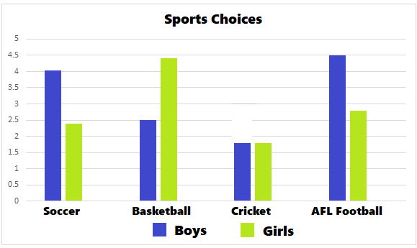 | Which sport did most boys choose?
 | Which sport did most girls choose?
 | Which sport was chosen equally by girls and boys?

Question 4 – Look at the table and answer the question. | Assessor use ✓ / ✘
Four friends are playing a game. The friend with the highest score wins.  NAME SCORE  Amy 76.076  Ben 67.660  Scott 76.770  Jess 66.607  . | Who wins the game?
 | Who came last?

Question 5 – Read and answer the calculations question. | Assessor use ✓ / ✘
A lift has sign which reads that the maximum weight capacity is 200kg?  Can 3 people who all weigh 80kg each safely use this lift at the same time? |  | ANSWER?  YES / NO

Question 6 – Read and answer the calculations question. | Assessor use ✓ / ✘
A wheelbarrow weights 6 kg when empty. It is filled with 28 kg of sand.  What is the total wight of the wheelbarrow filled with sand? |  | ANSWER?

Question 7 – Read and answer the calculations question. | Assessor use ✓ / ✘
A Forklift needs to lift a pallet of boxes. There are 4 boxes on the pallet weighing 20kg each. The pallet itself also weighs 20kg.  What is the total weight of the pallet and 4 boxes? |  | ANSWER?

Question 8 – Read and answer the calculations question. | Assessor use ✓ / ✘
A water tank contains 1000 Litres of water. A hole in the tank has begun to leak 10 Litres of water per minute.  If the tank is fixed in 10 minutes, how much water will be left in the tank? |  | ANSWER?

WRITING
Question 9 – Read the statement below and complete instructions | Assessor use ✓ / ✘
Briefly write in the space below why you are completing this course with Star Training today. Aim for at least 20-30 words. You can include things such as who booked the course for you, your job industry or your career goals. (Remember: This is not a spelling test).

__________________________________________________________________________________

__________________________________________________________________________________

__________________________________________________________________________________

OFFICE USE ONLY
RESULT OF LLN ASSESSMENT | ☐ APPROPRIATE TO ENROL ☐ NEEDS FURTHER ASSISTANCE
ACTION TAKEN BY ASSESSOR / FEEDBACK GIVEN TO STUDENT

