
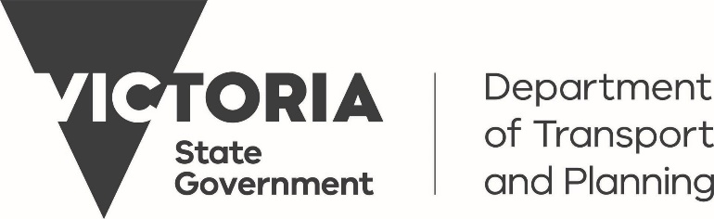

TMA Qualification - Victoria

Contents
What Training is Required In Victoria? 3
Training Requirements 3
How Do I Gain The Traffic Management Implementer Qualifications? 4
What Is The Course Content for Traffic Management Implementation? 4
Will I Be Issued With a Certificate? 4
What If I Change My Mind and Wish to Complete the Skill Set 4
Is A Refresher Required? 5
Who Can Deliver The TMA Course? 5

What Training is Required In Victoria?
To be regarded as a competent person – Truck Mounted Attenuator (TMA) Driver the following must be completed:
- Hold a current and valid Heavy Vehicle drivers’ licence of a suitable class to operate the TMA vehicle.
- Hold the Traffic Management Implementation non-practitioner Statement of Completion at the appropriate road category.
- Hold Construction Safety Awareness Training Card (commonly referred to as White Card)
- Have completed RIRTM301 Operate a truck or trailer mounted attenuator.

Please note additional entry requirements below

Training Requirements
A TMA driver must hold a non-practitioner qualification for the road category they are working on. A Certificate of Completion will be issued on successful completion of the course.
Non-Practitioner Training Requirements
Qualification Required | Category 1 Road | Category 2 Road | Category 3 Road
Qualification Required | Traffic Management Implementer 1 – Non Practitioner | Traffic Management Implementer 1 – Non Practitioner  AND  Traffic Management Implementer 2 – Non Practitioner | Traffic Management Implementer 1 – Non Practitioner  AND  Traffic Management Implementer 3 – Non Practitioner
Days Training Required | Two | Two (TMI1)  One (TMI2) | Two (TMI1)  One (TMI3)

How Do I Gain The Traffic Management Implementer Qualifications?
You can gain the appropriate Traffic Management Implementer qualification by completing a non-practitioner course.
A non-practitioner course is a theory only course (no post course practical required) designed for workers who do not directly undertake temporary traffic management roles at worksites, that is they need to know about traffic management, but do not perform a traditional traffic management role.
If, as a TMA Driver, you are conducting Traffic Management Implementation duties and/or Traffic Controller duties then you MUST complete and obtain the full skill set(s) for category of road you are working on.

What Is The Course Content for Traffic Management Implementation?
You will complete all the theory, theory assessment and any simulated assessment but will not complete the post course practical training required.
For example – if completing Traffic Management Implementer 1 non-practitioner course over two days you will participate in all class theory, theory assessment and simulated assessment.

Will I Be Issued With a Certificate?
On successful completion of the course you will receive a Statement of Completion which states which Traffic Management Implementer qualifications you have successfully completed. This Certificate will also have the statement below
This statement provides the individual with non-practitioner status which excludes the individual from performing the function of a Traffic Management Implementer or Traffic Controller

What If I Change My Mind and Wish to Complete the Skill Set
If you wish to complete the full skill set you will need to enrol in and complete the requirements of the skill set including meeting any pre-entry requirements within six months of successfully completing your non-practitioner training.

Is A Refresher Required?
More information regarding refreshers will be available later, at this stage it is anticipated that a non-practitioner will be required to complete refresher training every three years.

Who Can Deliver The TMA Course?
Only Approved Training Providers may deliver a theory only course, a list of Approved Training Providers is available Find an Approved Training Provider | Austroads

For further information please contact an Approved Training Provider or email ttmtraining@austroads.gov.au

